**Wireframe Document**

**Amazon Sales and Revenue**

**Rashmi Dubey**

**Home Page**

As per the problem statement, we have divided analysis into three sections:

1. Sales Analysis

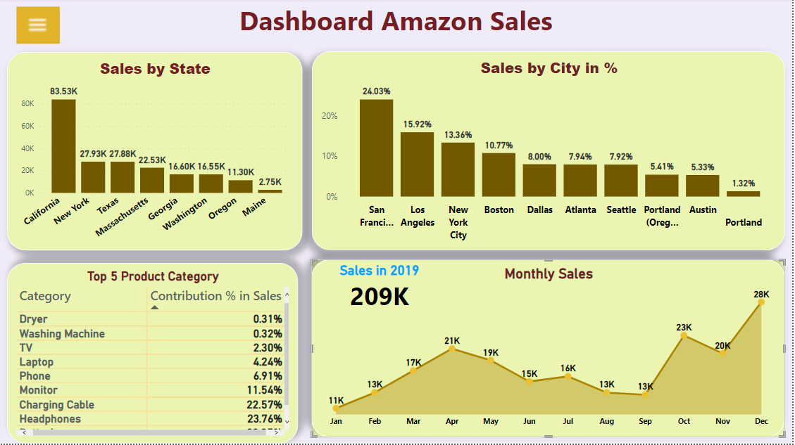

1. **|** P a g e

In this section we have created our first dashboard and tried to interpret following insights :

* + **Sales Distribution between various states**

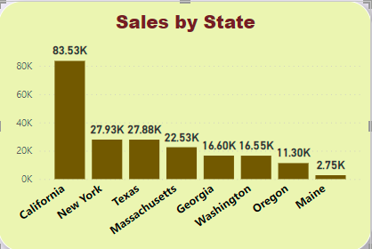

* **City’s Contribution in Sales ( in %) in Total Sales**

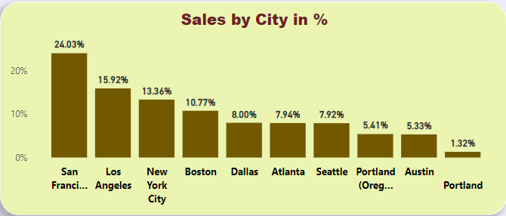

1. **|** P a g e
   * **Product’s Category-wise distribution (in %) of Sales**

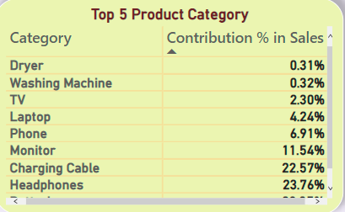

* + **Monthly Sales figure and Total Sale in Year 2019**

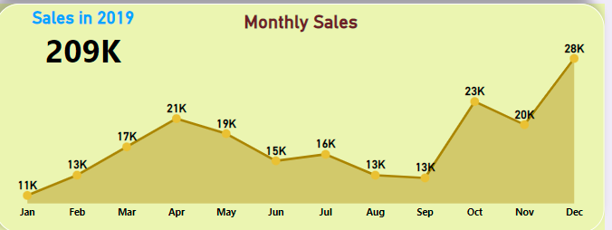

1. **|** P a g e
2. Revenue Analysis

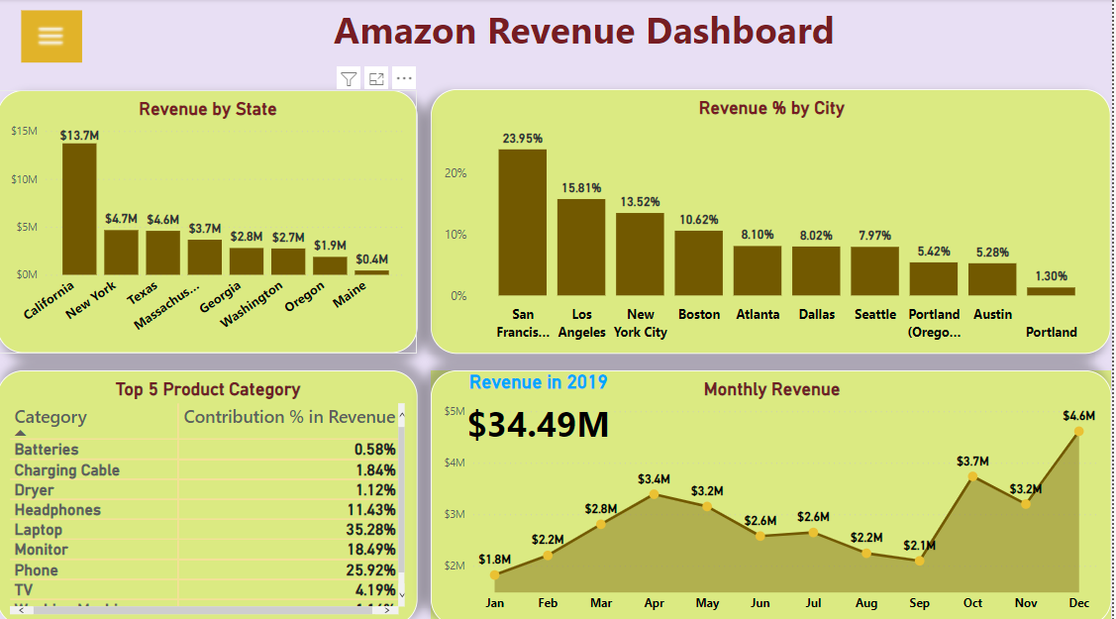

In this section we have designed our second dashboard and interpret the following insights :

* + **Revenue Distribution between various states**

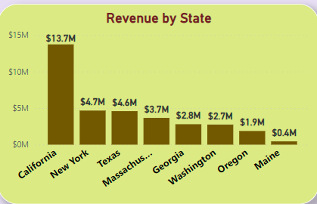

1. **|** P a g e
   * **City’s Contribution in Revenue ( in %) in Total Sales**

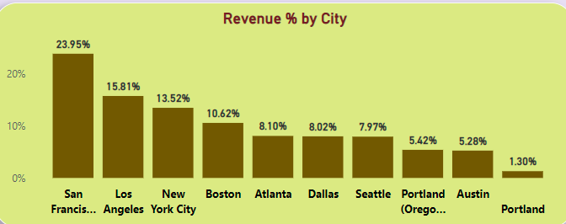

* + **Product’s Category-wise distribution (in %) of Revenue**

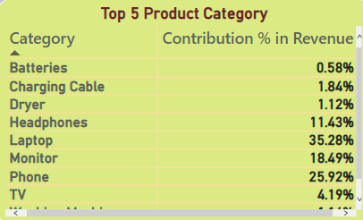

1. **|** P a g e
   * **Monthly Revenue figure and Total Revenue in Year 2019**

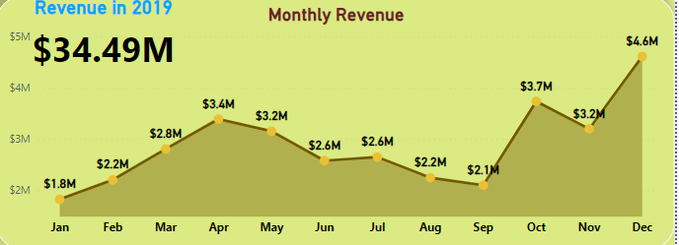

1. **|** P a g e